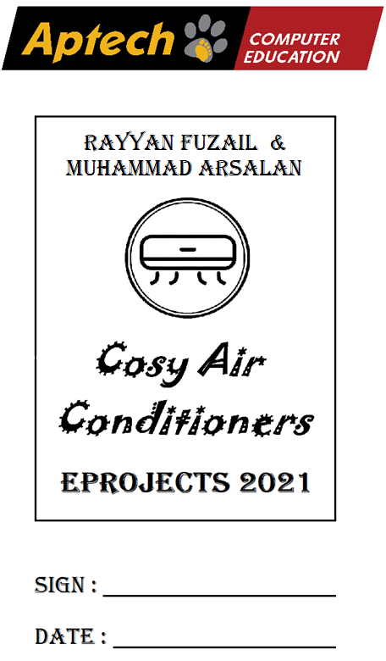

**Index**

|  |  |  |
| --- | --- | --- |
| **#** | Title | Pg # |
| **1** | **Introduction** | 3 |
| **2** | **Objectives** | 4 |
| **3** | **Problem Statement** | 5 |
| **4** | **The Project** | 6 |
| **4.1** | **1. Navigation Bar** | 6 |
| **4.2** | **2. Home** | 7 |
| **4.3** | **3. About Us** | 8 |
| **4.4** | **4. Contact Us** | 9 |
| **4.5** | **5. Products** | 9 |
| **4.6** | **6. Footer** | 11 |
| **5** | **Responsiveness** | 11 |
| **6** | **End Statement** | 11 |

**Introduction**

The thirst for learning, upgrading technical skills and applying the concepts in real life environment at a fast pace is what the industry demands from IT professionals today. However busy work schedules, far-flung locations, unavailability of convenient time-slots pose as major barriers when it comes to applying the concepts into realism. And hence the need to look out for alternative means of implementation in the form of laddered approach.

The above truly pose as constraints especially for our students too! With their busy schedules, it is indeed difficult for our students to keep up with the genuine and constant need for integrated application which can be seen live especially so in the field of IT education where technology can change on the spur of a moment. *Well, technology does come to our rescue at such times!!*

**What is eProject?**

eProject is a step-by-step learning environment that closely simulates the classroom and Lab based learning environment into actual implementation. It is a project implementation at your fingertips!! An electronic, live juncture on the machine that allows you to

* Practice step by step i.e. laddered approach.
* Build a larger more robust application.
* Usage of certain utilities in applications designed by user.
* Single program to unified code leading to a complete application.
* Learn implementation of concepts in a phased manner.
* Enhance skills and add value.
* Work on real life projects.
* Give a real life scenario and help to create applications more complicated and useful.
* Mentoring through email support.

The students at the centre are expected to complete this eProject and send complete project along with the documentation to eProjects Team

Looking forward to a positive response from your end!!

**Objectives of the project**

The Objective of this program is to give a sample project to work on real life projects. These applications help you build a larger more robust application.

The objective is not to teach you JavaScript/Dreamweaver but to provide you with a real life scenario and help you create basic applications using the tools.

You can revise the chapters before you start with the project.

This project is meant for students who have completed the module of ***Dreamweaver***. These programs should be done in the Lab sessions with assistance of the faculty if required.

It is very essential that a student has a clear understanding of the subject. Students should go through the project and solve the assignments as per requirements given.

Kindly get back to eProjects Team in case of any doubts regarding the application or its objectives.

**Problem Statement**

COSY AIRCONDITIONERS is selling various types of AIR CONDITIONERS. The company advertises by distributing the pamphlets, advertising on television and so on. Due to rapid development in internet field, the company decides to launch a website where people will get all the information about the various products available with them easily.

**Requirement Specification:**

The Web site is to be created based on the following requirements.

1. The Home Page should be created making use of Sections with a suitable logo.
2. Home Page should contain details of Air Conditioners with suitable images.
3. The site should display a menu which will contain the options for brief introduction about the various air conditioners available, location of the shop and any other information if required.
4. The information should be categorized according to the brand names of the products like if a User wants to see only “WHIRLPOOL” products or any other companies’ products then he/she can click on a Link/button/menu etc and can see only that Brand products.
5. When a user selects any particular brand, a list of products for that brand will be displayed
6. A brief summary of features of individual products should be displayed on the Web Page along with the product but detailed Features should be stored in Individual Word documents which can be downloaded or viewed by the User who wishes to see the same.
7. The user should also be able to compare the various products of different as well as similar brands.
8. There should be a “Contact Us” page which will have the Address of the Company which is as follows and the mail address which when clicked will invoke the local mail client from where they can send an email.

**The Project**

**Introduction:**

This is an E-Commerce website named Cosy Air Conditioners which is, as clear from its’ name, about selling Air Conditioners. The creators of this website are Rayyan Fuzail and Muhammad Arsalan, thankful students of Aptech. While making this website we kept the important requirements in our mind so that we will fulfill all of them. We worked with complete passion and hard work to make this website as best as we can. We used HTML, CSS and JavaScript and some libraries and frameworks from the internet, based on our knowledge about them. Also, instead of some Lorem words, all of the text in this website is meaningful. The components of this Website are as follows:

**Components:**

We created this website using separate sections in the webpage. There are 4 webpages including Home, About Us, Contact and obviously, as its’ an E-Commerce website, a Products page which is then further divided into three section followed by the three types of most commonly used Air Conditioners all over the globe. See more details about them below:

**1. Navigation Bar:**

For the Navigation bar, we went minimalistic. We used a native Navigation Bar from Bootstrap4 as it fulfills our requirements. It follows minimalism as well as it’s responsive. Responsiveness was also a big deal for us and we worked hard for it. Read more about it further in this documentation. With a logo of our brand which we created ourselves, we also gave a search bar in the Navigation Bar but it wasn’t functional as we haven’t studied that yet. But we will, in the next Project as soon as we are taught.



**2. Home:**

Homepage is the first thing a user sees when he visits the website so its mandatory to make it as engaging and attractive as possible in order to keep the user from getting bored. We used a lot of CSS and JavaScript to make it dynamic as well as animated. As mentioned earlier, we used sections in this webpage. There are 4 sections excluding Navigation Bar and footer. There’s also a fixed button for you to get to the top from any section.

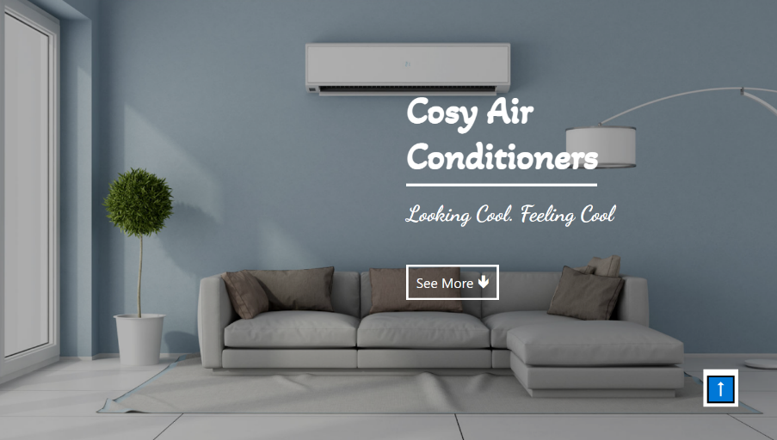First section has the name and slogan of the website with a beautiful and calming image which gives a feeling of comfort as it is our objective, to make you feel comfortable. We also included a button using JavaScript which, when clicked, takes you to second section.

In the second section we mentioned some features of our products with some eye-catching animations.

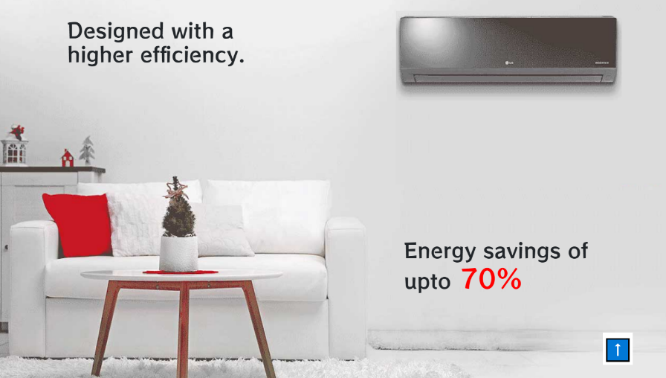

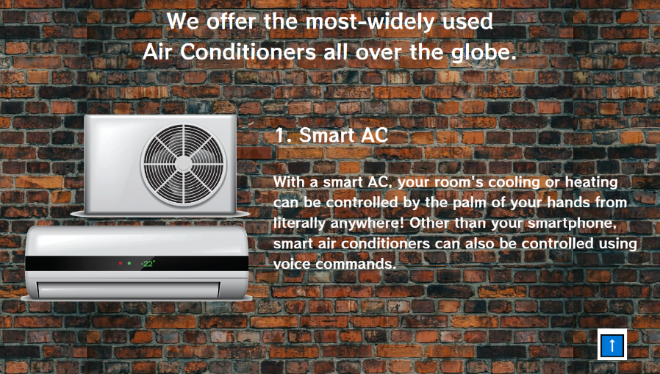Moving on, the third section contains details about types of Air Conditioners to provide the user information about the products he’s buying.

Last but not the least, there is the fourth section in which we gave a link to our products page to take the user there after he’s done reading about our products.

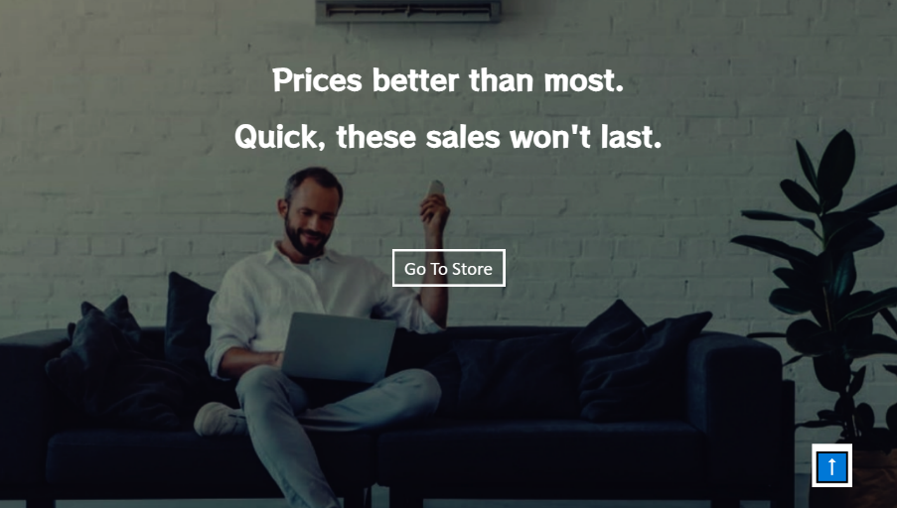

**3. About Us:**

In the about section, we provided fundamental details about ourselves, what we do and our Vision and Mission Statement. It describes out motives well to satisfy the buyer. We also provided our location there, which you can get to precisely with the help of Google Maps coordinates.

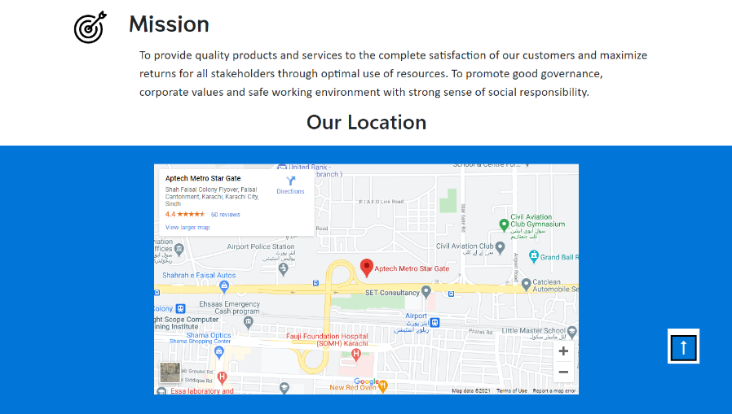

**4. Contact Us:**

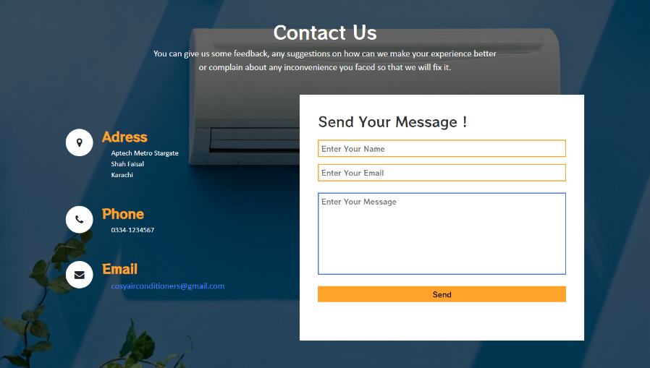Contact Us Page is made up of two section, a read-only details, a feedback form for you to fill as well as a landing conformation page. You can either give feedback, give a suggestion on how to improve, or complain about any inconvenience you faced while dealing with us so that it won’t happen again. We also validated it.

**5. Products:**

As the main objective of this website, we created the Product page simple, user friendly and less confusing than other websites which have a lot of options which confuse users. Our interface for this page was minimalistic as well. We placed a slider on the top as nice view to look at when you land on the page. It has three photos which describes the three types of Air Conditioners which we’re selling with beautiful images. We also gave a filter list at the left, if you want to see products of a particular brand. It was also one of the requirements of this project which, just like all of the others, got fulfilled.

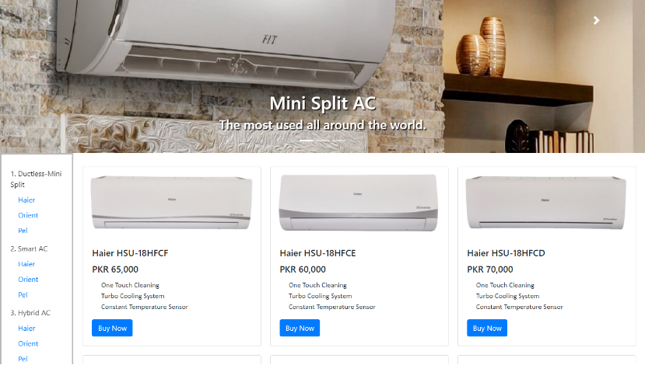

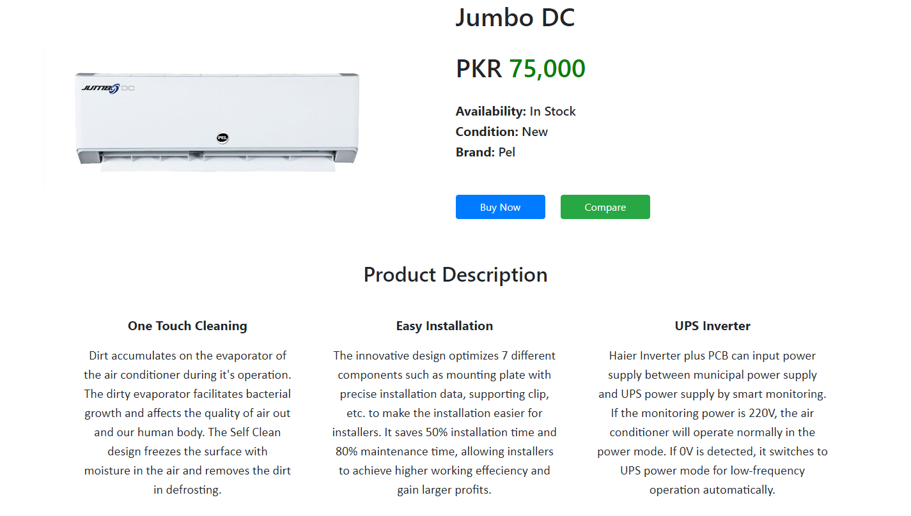Then, there are product cards which we made using Bootstrap Cards component. We provided suitable pictures and prices in the cards. Below them there is summary of feature of that products. After clicking them, you’ll be redirected to that product’s page where you can see the details of that product. But we provided even more details for advance users who know about technical terms. They are in a Word Document which you can download from the button at the bottom.

On the products’ side, there are two buttons. One to click when you’ve made up your mind to buy a product. It will take you to the checkout page where you can insert your credentials to order it. Our products arrive in not more than 15 days. A second button is for you to compare our products side by side. This part took most of the time.

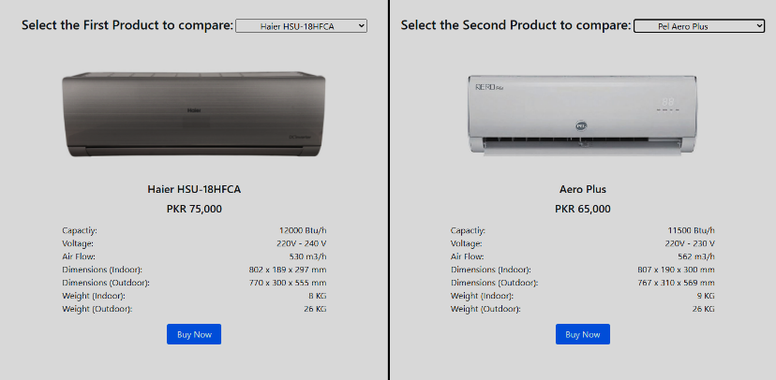

**6. Footer:**

Footer was a work of art itself. Similar to the whole project we used section in it. In this case, three. In the First section we’ve put the logo and social media links. We used font awesome for that which is a great library for symbols. We styled the social media symbols to change their color accordingly to their accurate official color code. The second section contains links to other pages such as, about, privacy policy, terms, etc. We also created those pages while giving meaningful words and policies. Then comes the third and last section of the footer in which we gave an option to subscribe to our newsletter if you want. Which has a nice animation to confirm the subscription. We also made all of these components responsive. See more about responsiveness below:

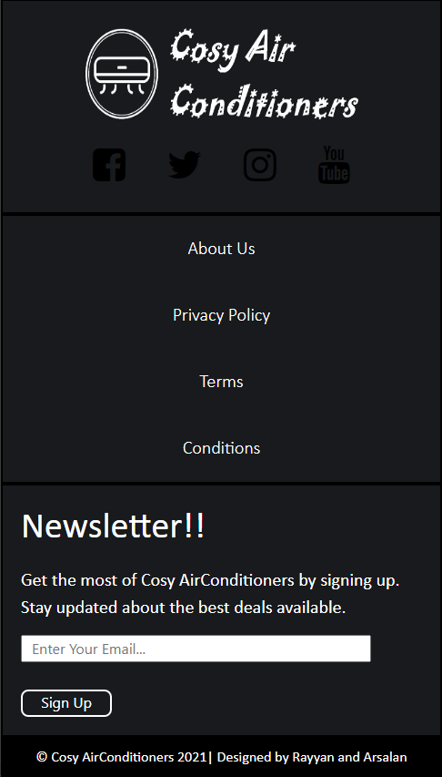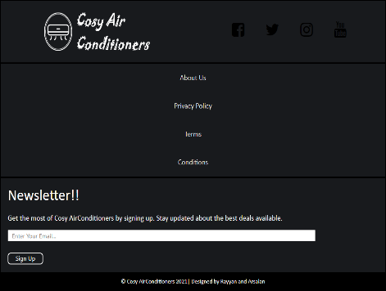

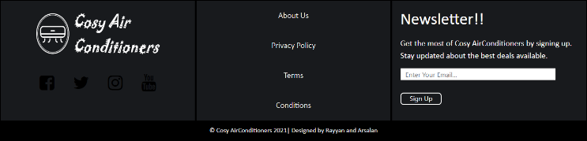

**Responsiveness:**

Making the website Responsive was the most challenging part for us. But we puuled it with the help of Aptech teachers and the internet. We used Media Query to keep the responsiveness simple and fast. Take a moment or two to see the pages with diferent size. We made it as responsive as the browser window could get. Beyond that it won’t work as everything has a limit. There are majorly three sizes we worked on. Widescreen sizes, Square Monitors and Tablets, as well as potriat view for mobile. But it’s not made for bigger screens apart from HD, like 4K or even 8K. But just to be safe we used size units like “vw”, “vh” and “%” as they are relative to the screen aspect ratio. Hopefully it will remain in shape in those screens too.

**End Statement:**

Lastly, it was as informative as it was fun making this website. We got to learn a lot by taking all the teachings and thoeries into practical. Being time-consuming and complex, it also taught us the importance of time and disciplince. Coding was hard before but after making this we improved our logic building and how to do more with less code. Because of the requirements we reviewed the website to see if it’s fulfilling all of them. We hope it would meet your criteria as well. Looking forward to your reasponse. Thanks !